IB Biology Name ______________________________
Chicken Wing Dissection Lab Period _______ Date _____________

Purpose
- To explore the relationships among tendons, fascia, ligaments and bones in the functioning of a chicken wing.
- To compare a chicken wing to a human arm.

Materials
chicken wing (fresh), gloves, dissecting tray, dissecting kit, cleaning supplies, paper towels

Safety
Since fresh chicken contains salmonella, which can cause food poisoning, it is important that you keep chicken juice away from your mouth. For this reason, you are to wear gloves, work in a clean, contained area. Wear your gloves until after cleaning your equipment and area with disinfectant soap. Dry all materials and dispose of the cleaning rags as directed. Dispose of the gloves in the crock. Wash your hands and your pencil.

Examining the Chicken Wing

1. Rinse the chicken wing under running water. Dry it thoroughly with paper towels and place it in the
dissecting tray.

- Remove the skin from the chicken wing. With the forceps, grasp the skin near the shoulder and pull the skin away from the underlying muscles. Use scissors to cut the skin along the entire length of the chicken wing. CAUTION: Be careful when handling sharp instruments. Cut in a direction away from your hands and body. Make sure you cut the skin exactly as shown in Figure 1. Note: Be careful not to cut through the underlying muscles with the scissors.

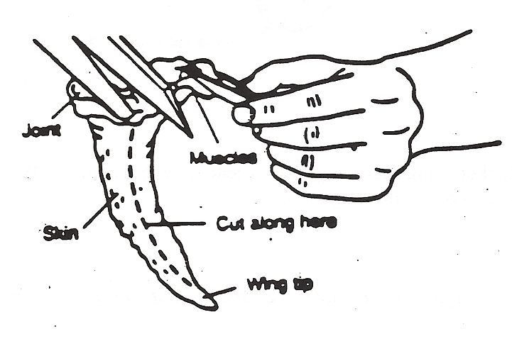

- Carefully pull of the skin. Observe the fascia, the transparent connective tissue that surrounds the muscles and holds the muscles to the skin. With a probe or scalpel, gently separate the fascia from the skin. Note: The skin covering the joints is difficult to remove. Work carefully, using scissors or a scalpel to remove the skin. Remove the skin up to the second joint. It is not necessary to remove the skin from the wing up. Cut away the excess skin around the second joint. Discard the skin according to your teacher’s instructions. Note: You may want to wash your hands and rinse the chicken wing at this time.

- Observe the muscles in the chicken wing. Observe the tendons, the shiny white cords of connective tissue at the ends of the muscles. Tendons attach muscles to bones.

- Grasp the wing by the shoulder and the wing tip. As you bend and straighten the wing, notice how the muscles contract as they move. Locate and identify the antagonistic muscles, which are pairs of muscles that work in opposition to each other. Thoroughly wash your hands with soap and water.

- On the blank sheet of paper, draw the muscles and bones of the chicken wing. Label the 3 bones and 3 muscles by name, at least one tendon, at least one ligament, an antagonistic muscle pair, and the insertion and origin of one muscle.

- Examine Figure 2, which shows the muscles and bones of the human arm. The elbow joint, which is a hinge joint, is similar to the joint in the chicken wing. On Figure 2, locate the tendons that attach the muscles to the bones. As a muscle contracts, the attachments either remain stationary or move. The attachment end that moves a bone is called the insertion. The attachment end that remains stationary, anchoring the muscle, is called the origin. Locate the origins and insertions in the chicken wing.
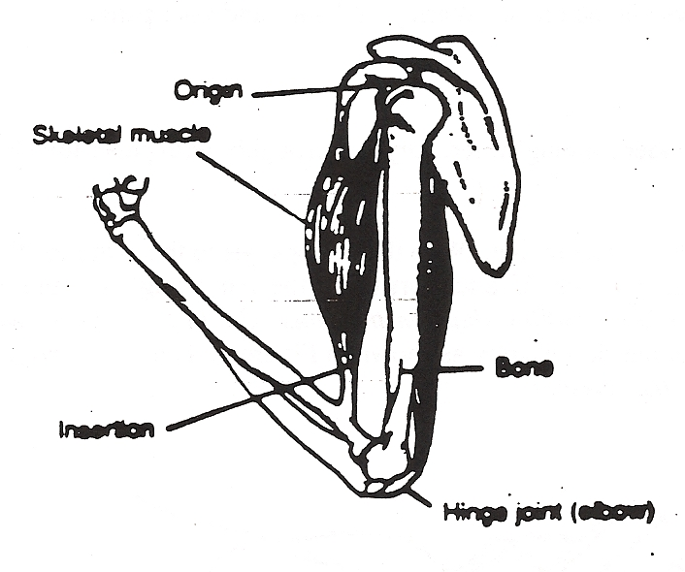

- Dispose of the dissected chicken wing according to your teacher’s instructions. Wash, dry, and put away the dissecting tools used in this part of the investigation.

Analysis/Conclusions

Write answers to these questions on a piece of notebook paper of on the back of your drawing. Be sure to give complete, detailed answers.

- What enables the chicken to move its wing?

- How might injury to one of the muscles in an antagonistic muscle pair affect movement?

- Compare and contrast the wing of a bird to the arm of a human. Use the skeleton on display to assist with your comparison.

- List as many things as possible that could interrupt the functioning of these limbs.

